Name: Quang Huynh

A Closer Look at the Nephron

Directions: Use your online text to help you color, label and describe parts of the nephron below.

The functional unit of the kidney is the nephron. It is here that material is filtered from the blood; some material is lost in the urine while other material is reabsorbed back into the cardiovascular system. The renal corpuscle of the nephron includes the glomerulus and the glomerular (Bowman's) capsule, while the renal tubule consists of everything beyond the glomerulus.

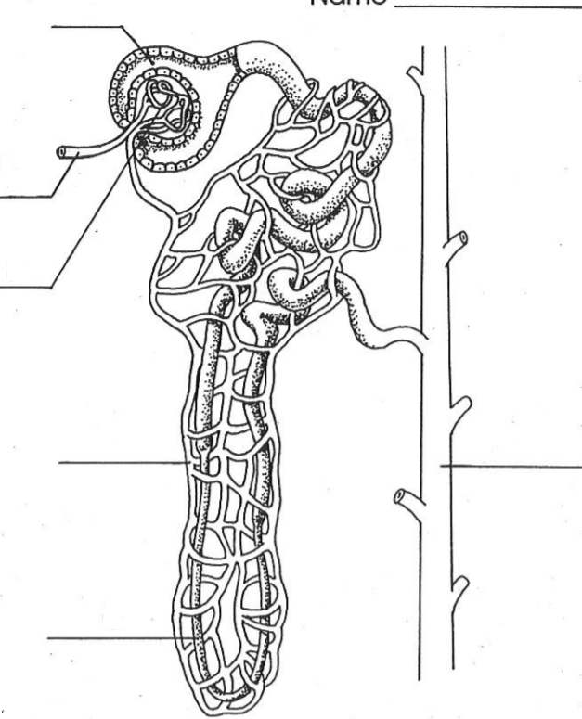



Color and Label:

* a- Collecting tubule



* b- Glomerulus



* c- Bowman’s capsule



* d- Distal tubule



* e- Renal arteriole



* f- Loop of Henle



* g- Proximal tubule



* h- Capillaries



**What structures make up the renal corpuscle?**



The renal corpuscle is made up by the Glomerulus and the Bowman’s capsule.



**What structures make up the renal tubule?**



The renal tubule is made up of the proximal tubule, the

distal tubule and the loop of

Henle.

Describe: Briefly explain the role of each part of the nephron listed below.

|  |  |
| --- | --- |
| **Structure** | **Role in excretory function** |
| Collecting tubule | Absorbs water and concentrates urine |
| Glomerulus | Filters blood |
| Bowman’s capsule | Filters blood to form urine |
| Loop of Henle | Reabsorbs water and sodium chloride from the filtered blood |
| Renal arteriole | Regulates blood pressure |

Explain: The diagram below indicates that the nephrons remove wastes from the blood by the process of filtration and reabsorption. Filtration takes place in the glomerulus, and reabsorption takes place in the Loop of Henle.

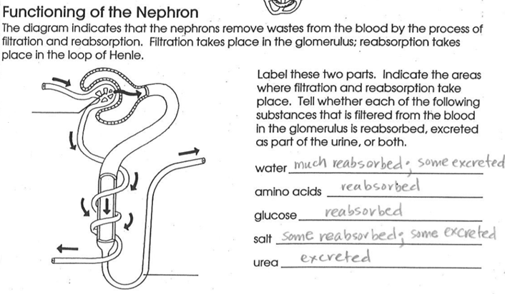Label the **glomerulus** and the **Loop of Henle** in the diagram below. For each substance listed below write whether the substance filtered from the blood in the glomerulus is *excreted, reabsorbed or both*.

Water **Reabsorbed**

Amino acids **Reabsorbed**



Glucose **Reabsorbed**

Salt **Excreted**

Urea **Excreted**

**Why do you think the kidneys are considered “regulatory” organs?**

I believe the kidneys are considered the regulatory organs since they regulate the fluids in the body.

